LAB Q A.1

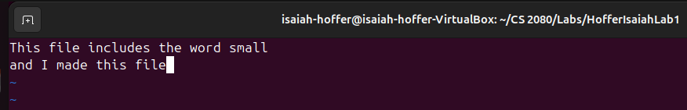

LAB Q A2.1



LAB Q A2.2

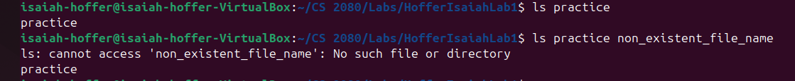

LAB Q A2.3



LAB Q A3



LAB Q A4



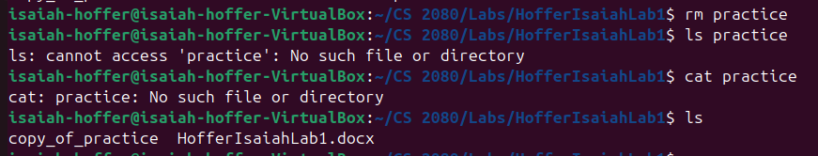LAB Q A5

LAB Q A6

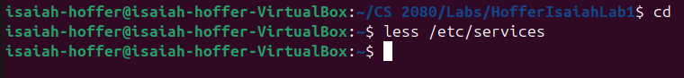

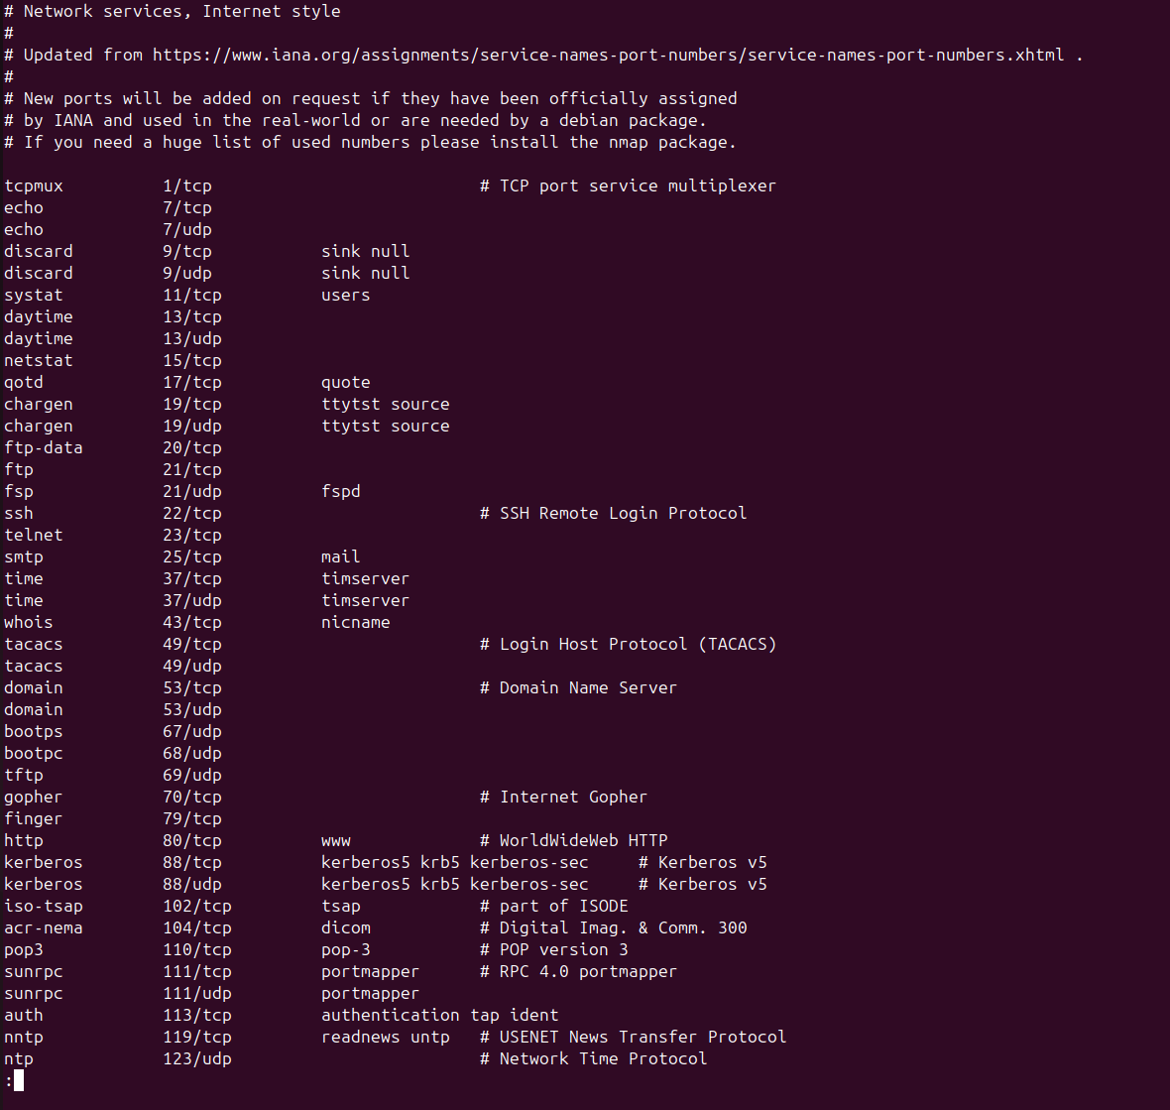

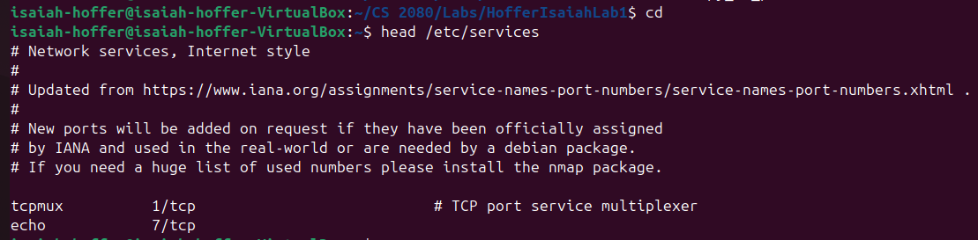LAB Q A7

LAB Q A8

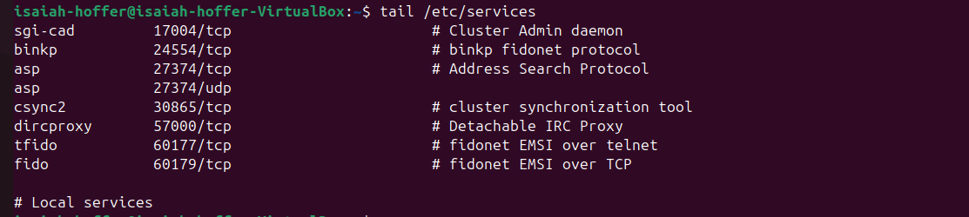

LAB Q A9

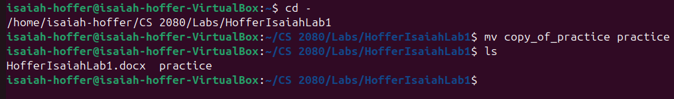

LAB Q A10



LAB Q A11



LAB Q A12.1

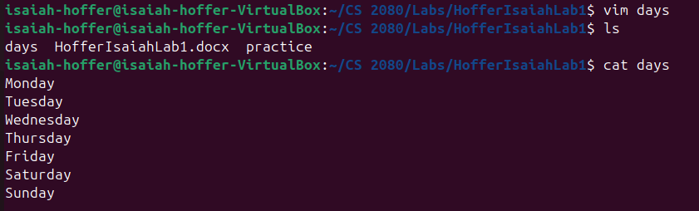

LAB Q A12.2

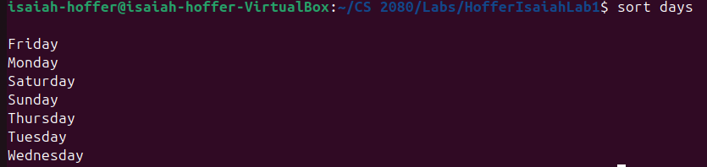

LAB Q A13

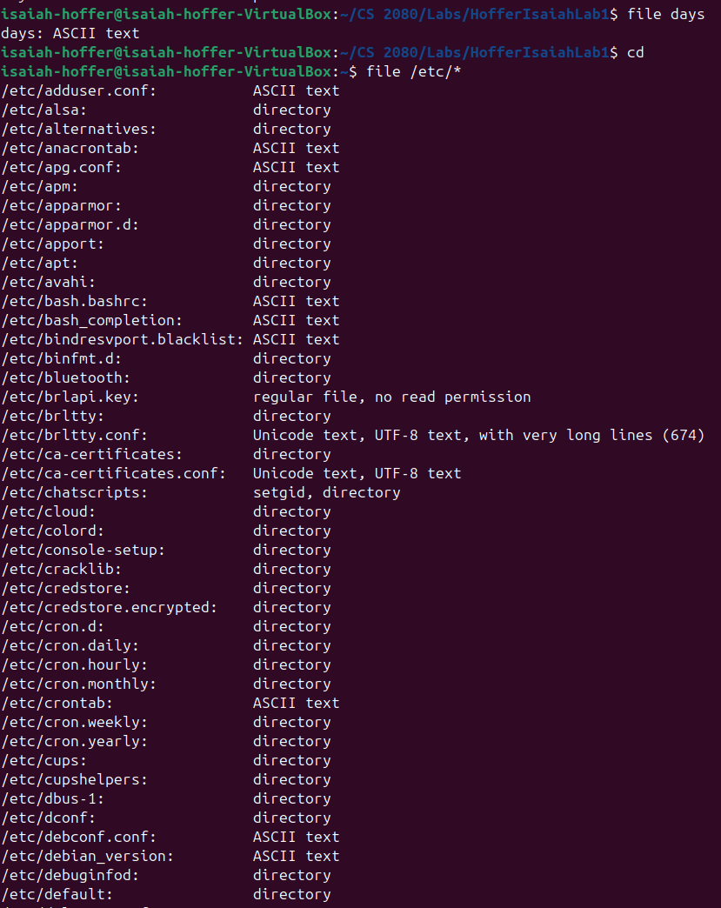

LAB Q B1-2

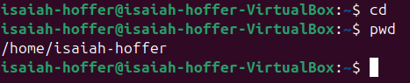

LAB Q B3.1

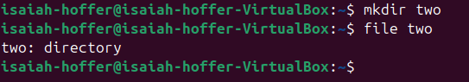

LAB Q B3.2

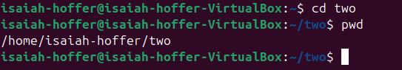

LAB Q B4

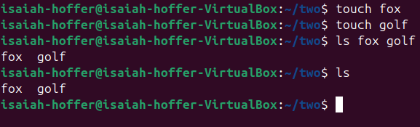

LAB Q B5.1

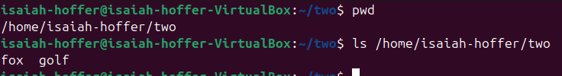

LAB Q B5.2

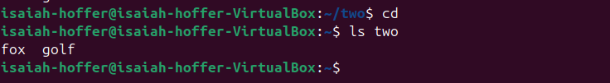

LAB Q B6.1



It failed because rmdir command can only remove empty directories

LAB Q B6.2

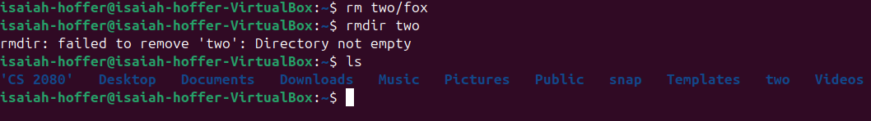

It still failed because there is still another file inside two

LAB Q C1

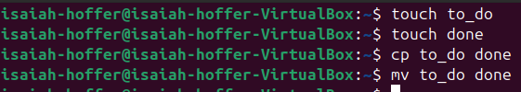

First it created two files, to_do and done, then it copied to_do and replaced the file named done with the copy of to_do because the command had the same name, then it ended with renaming to_do with done, but since we already have a file named done it replace done file with the renamed to_do file

LAB Q C2

ls -al

LAB Q c3

cd /etc